

TRIBHUVAN UNIVERSITY
FACULTY OF HUMANITIES AND SOCIAL SCIENCES

A Project Proposal on
ONLINE BUS TICKET RESERVATION SYSTEM

Submitted to
Department of Computer Application
Southwestern State College, Basundhara, Kathmandu

In partial fulfillment of the requirements for the Bachelors in Computer Application

Submitted by
Name: Prabita Adhikari

TU Reg. No:

27/05/2026

ACKNOWLEDGEMENT

I would like to express my sincere gratitude to my supervisor for their guidance and support throughout this project. Their advice and encouragement helped me in planning and developing the system successfully.

I would also like to thank my friends and classmates for their suggestions and feedback, which helped improve the project.

Finally, I acknowledge the existing online bus ticket systems, such as BusSewa, which I studied to understand practical features and implement the project in a simple and effective way.
This project would not have been possible without the support and guidance from all of them.

With Regards,
Prabita Adhikari
TU Reg No:

ABSTRACT

The Online Bus Ticket Management System (OBTMS) is a web-based academic project designed to automate the bus ticket booking process. In many areas of Nepal, passengers face long waiting times at physical ticket counters, especially during festivals and holidays, which can lead to inconvenience and inefficiency. This system provides a digital solution for managing bus bookings by allowing users to search buses, view schedules, select seats, and book tickets online.

Administrators can manage buses, routes, schedules, and booking records efficiently using CRUD operations. The system is developed using HTML, CSS, JavaScript, PHP, and MySQL, and is deployed on a local server environment for academic purposes. It incorporates proper validation, authentication, and database management to ensure reliability and security. This project demonstrates how digital technology can improve traditional manual processes in a simplified academic environment.

Keywords: Online Bus Ticket Management, CRUD Operations, PHP, MySQL, Local Server, Digital Ticket Booking.

Table of Contents
ACKNOWLEDGEMENT ii
ABSTRACT iii
LIST OF FIGURES v
LIST OF TABLES vi
LIST OF ABBREVIATIONS vii
1. INTRODUCTION 1
2. PROBLEM STATEMENT 2
3. OBJECTIVES 3
4. METHODOLOGY 4
a. Requirement Identification 5
i. Study of Existing System 5
ii. Requirement Collection 6
b. Feasibility study 8
i. Technical feasibility 8
ii. Operational feasibility 8
iii. Economic feasibility 8
c. System Flowchart 9
5. GANTT CHART 10
6. EXPECTED OUTCOMES 11
7. BIBLIOGRAPHY 12

LIST OF FIGURES

Figure 1:Waterfall Model of OBTMS 5
Figure 2:Use Case Diagram of OBTMS 7
Figure 3: System Flowchart of OBTMS 9

LIST OF TABLES

Table 1: Gantt chart of OBTMS 10

LIST OF ABBREVIATIONS

CRUD Create Read Update Delete
CSS Cascading Stylesheet
HTML Hypertext Markup Language
MYSQL Structured Query Language
OBTMS Online Bus Ticket Management System
PHP Hypertext Preprocessor
XAMPP Cross Platform Apache MariaDB PHP Perl

INTRODUCTION
The advancement of web technologies has made it possible to automate many traditional systems, including transportation and ticket booking services. In many small organizations and academic environments, manual ticket management systems are still used, which can lead to booking errors, difficulty in maintaining records, and inefficient management of customer information. To solve these problems, a computerized ticket management system can be developed.
The Online Bus Ticket Management System (OBTMS) is a web-based academic project designed to manage bus ticket booking and related operations in a simple and efficient manner. The system is intended to run on a local server environment for educational and demonstration purposes. It allows users to search buses, view schedules, book tickets, and manage reservations through a digital interface, while administrators can manage buses, routes, schedules, and customer records.
The project is developed using technologies such as HTML, CSS, JavaScript, PHP, and MySQL, and is executed using a local server platform such as XAMPP. The system implements CRUD (Create, Read, Update, Delete) operations, database connectivity, form validation, and user authentication to demonstrate the practical implementation of web-based application development concepts.
The main objective of this project is to provide a simple, user-friendly, and efficient ticket management system while gaining practical knowledge of frontend development, backend programming, and database management in a local development environment.

PROBLEM STATEMENT
In many areas of Nepal, bus ticket booking is still managed manually through physical ticket counters. During major festivals and holiday seasons, a large number of people travel from cities to their hometowns, which creates overcrowding and long waiting times at ticket counters. Passengers often have to stand in queues for several hours just to purchase a ticket. This process is time-consuming, inconvenient, and difficult to manage efficiently.
I personally experienced this problem while traveling to my hometown during a major festival in Nepal. I had to wait approximately 2–3 hours in line to get a physical bus ticket. The situation became more challenging due to crowd management issues, lack of proper information about seat availability, and manual handling of bookings. This experience helped me realize the need for a more efficient and digital solution for bus ticket management.
As the world is rapidly transforming digitally and Nepal is also gradually adopting digital technologies in different sectors, there is a growing demand for online and automated services. However, many transportation services still rely on traditional manual systems, which can result in booking errors, poor record management, and inconvenience for passengers.
Therefore, this project proposes the development of an Online Bus Ticket Management System (OBTMS) that can simplify ticket booking and management processes through a web-based platform running on a local server for academic purposes. The system aims to reduce waiting time, improve booking efficiency, and provide a more organized and user-friendly approach to bus ticket management.

OBJECTIVES
The main objective of the OBTMS are as follows:

- To digitize the traditional manual bus ticket booking process.
- To reduce passenger waiting time during ticket booking.
- To provide easy bus ticket booking and management facilities.
- To manage buses, routes, schedules, users, and bookings efficiently using CRUD operations.

METHODOLOGY
System Methodology
For the Online Bus Ticket Management System (OBTMS), the Waterfall model is an ideal approach due to its sequential and structured nature. In this model, the project begins with a requirement analysis phase, where all functional and non-functional requirements are clearly defined, such as user registration, bus search, seat booking, admin management, and database CRUD operations. Once requirements are finalized, the system design phase establishes the architecture, including frontend components (HTML, CSS, JavaScript), backend logic (PHP), and database structure (MySQL), along with diagrams like use case and flowcharts.

In the implementation phase, coding is carried out according to the design, first setting up the database, followed by backend scripts and frontend pages. This is followed by testing, where each module is verified for functionality, reliability, and correct database interaction, ensuring that booking and administrative operations work as expected. After successful testing, the system is deployed on a local server environment (XAMPP) for academic demonstration. Finally, minimal maintenance is performed to address bugs or small enhancements.

Using the Waterfall model ensures that the project progresses in a logical, step-by-step manner, making it easier to manage, document, and submit, especially since the project scope and requirements are fixed and well-defined.

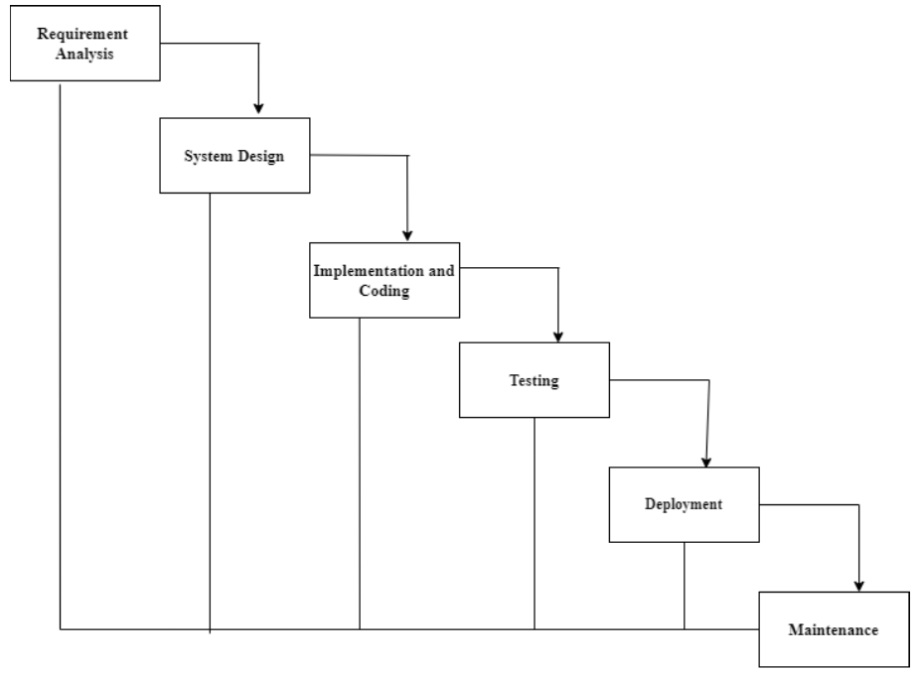
Figure 1:Waterfall Model of OBTMS

Requirement Identification

Study of Existing System
The existing system was studied by reviewing different online bus ticket booking platforms and transportation management websites related to Nepalese bus services, especially BusSewa [1], which is one of Nepal’s popular online bus ticket booking platforms. The study was conducted to understand the working mechanism, features, advantages, and limitations of current digital bus ticket management systems.
The reviewed system provides features such as online bus search, route selection, schedule viewing, seat selection, digital ticket booking, and booking management. Users can search buses by selecting departure location, destination, and travel date. The system also provides real-time seat availability and online booking facilities, making the ticket booking process faster and more convenient for passengers.
The study also showed that existing systems help reduce physical crowding at ticket counters, especially during major festivals and travel seasons in Nepal. Digital booking systems minimize long waiting times and improve ticket management efficiency.
However, many existing systems are large commercial platforms containing multiple services such as flights, hotels, vehicle rentals, and tours in addition to bus ticket booking. For this academic project, the focus is limited only to the bus ticket booking and management module. The proposed Online Bus Ticket Management System aims to implement the core functionalities of online bus ticket booking in a simplified academic environment using HTML, CSS, JavaScript, PHP, and MySQL on a local server.

Requirement Collection
The requirements for the proposed Online Bus Ticket Management System were collected through personal experience, observation, and analysis of the existing manual ticket booking system. I personally experienced difficulties during festival seasons while traveling to my hometown, where I had to wait for 2–3 hours in long queues to obtain a physical bus ticket. This highlighted the need for a more efficient and digital ticket management solution.
Different existing online bus ticket booking websites and related transportation management systems were studied and reviewed to understand their features, working mechanisms, advantages, and limitations. The study helped identify important system functionalities and user requirements needed for the proposed system.
The collected requirements were categorized into functional and non-functional requirements.

Functional Requirements
- The user shall have the ability to register and log into the system.
- The user shall have the ability to search available buses and view schedules.
- The user shall have the ability to select seats and book bus tickets.
- The user shall have the ability to view and cancel bookings.
- The admin shall have the ability to log into the admin panel securely.
- The admin shall have the ability to add, update, view, and delete bus details.
- The admin shall have the ability to manage routes and schedules using CRUD operations.
- The admin shall have the ability to manage booking records and customer information.
- The system shall have the ability to store and retrieve data from the database.

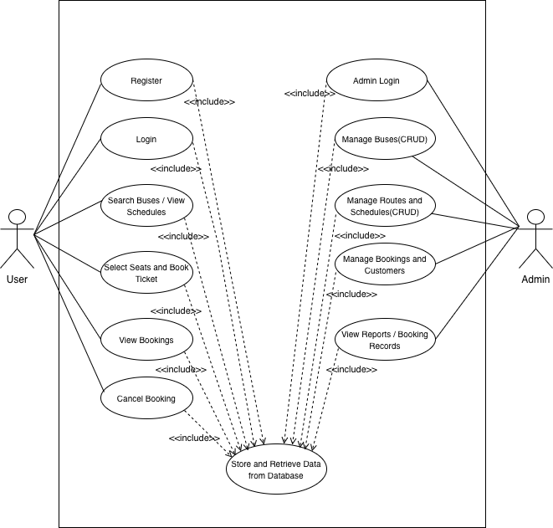
Figure 2:Use Case Diagram of OBTMS

Non-Functional Requirements
- The system must have reliable management and storage of booking records.
- The system must have secure authentication, validation, and session management.
- The system must have a responsive and user-friendly interface.

Feasibility study

Technical feasibility
The proposed system is technically feasible because it uses commonly available technologies such as HTML, CSS, JavaScript, PHP, and MySQL. The project will run on a local server environment using XAMPP, which is suitable for academic development and testing purposes.

Operational feasibility
The system is operationally feasible because it is designed to be simple, user-friendly, and easy to operate for both users and administrators. The digital system will reduce manual work and improve the efficiency of ticket booking and management.

Economic feasibility
The proposed system is economically feasible because it does not require expensive hardware or software. The technologies and tools used for development are freely available and open source, making the project cost-effective for academic purposes.

System Flowchart

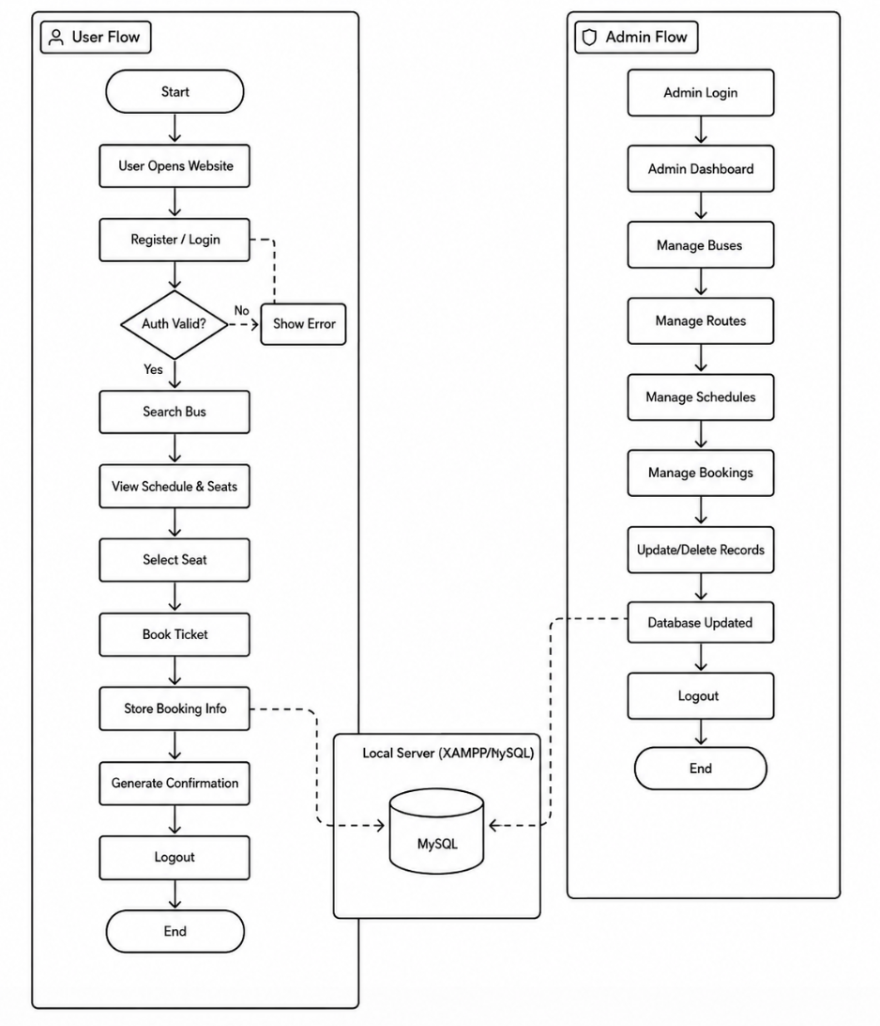
Figure 3: System Flowchart of OBTMS

GANTT CHART

Table 1: Gantt chart of OBTMS

Task | Jun 1 | Jun 7 | Jun 14 | Jun 21 | Jun 28 | Jul 5 | Jul 12 | Jul 19 | Jul 26 | Aug 2 | Aug 9 | Aug 16
Proposal Writing | ████ | ████
Requirement Analysis |  | ████ | ████
Planning & Design |  |  | ████ | ████ | ████
Implementation |  |  |  |  | ████ | ████ | ████ | ████
Testing & Supervision |  |  |  |  |  |  | ████ | ████ | ████
Documentation |  |  |  |  |  |  |  | ████ | ████ | ████
Final Submission |  |  |  |  |  |  |  |  |  |  | ████

EXPECTED OUTCOMES
The proposed Online Bus Ticket Management System (OBTMS) is expected to provide a simple, efficient, and user-friendly digital platform for managing bus ticket booking operations. The system will help reduce the difficulties of manual ticket booking by allowing users to search buses, view schedules, select seats, and book tickets digitally through a web-based application running on a local server.
The project is expected to minimize long waiting times, improve record management, and reduce manual errors in ticket handling. Administrators will be able to manage buses, routes, schedules, users, and booking records efficiently using CRUD operations.
The project will provide practical implementation experience in frontend development, backend programming, database management, validation, and authentication using HTML, CSS, JavaScript, PHP, and MySQL. The system is also expected to demonstrate how digital technology can improve traditional transportation management systems in an academic environment.

BIBLIOGRAPHY

[1] | BusSewa, "BusSewa," [Online]. Available: https://bussewa.com.np.

